PULSE -HEALTH CARE INFORMATION AND APPOINTMENT SYSTEM

Project Plan

Group members: TASK
- Huzaifa Aousaf -04072413023 (Team Lead)
- Rayyan Umer - 04072413037 (Team Member 2)
- Mujeeb Arshad-04072413034 (Team Member 3)

Submission date: 18/09/2026

Supervised by: Dr. Onaiza Maqbool

Department of Computer Science
QUAID-E-AZAM UNIVERSITY,ISLAMABAD

Signature Page
Name | Role | Signature
Huzaifa Aousaf | Team Leader
Mujeeb Arshad | Team member
Rayyan Umer | Team member

Change History:
VERSION | DATE | AUTHOR | CHANGES MADE
1.0 | 9/16/2026 | Huzaifa Aousaf | Initial Draft
1.1 | 9/18/2025 | Mujeeb Arshad | Review Document and add Member 2 and Member 3 tasks .

Remarks:



Preface:
This document is the project plan for PULSE, a web-based healthcare platform being developed for our Software Construction project. The plan follows ISO/IEC/IEEE 16326 guidelines and provides a structured approach to project execution, covering objectives, constraints, planning, and risk management. The goal is to make it easier for patients to find doctors, book appointments, and view their lab test results online.

Table of Contents
1. Project Overview: 5
1.1 Project Summary 5
1.2 Purpose, Scope, and Objectives 5
1.2.1 Purpose: 5
1.2.2 Scope: 5
1.2.3 Objectives: 5
1.3 Assumptions and Constraints 6
Assumptions: 6
Constraints: 6
1.4 Project Deliverables 7
1.5 Schedule Summary 7
2. References: 8
3. Definitions: 8
4. Project Context: 9
4.1 Process Model: 9
5.Project Planning 10
5.1 Project Work Plan 10
5.2 Work Activities 10
6. Supporting Process Plans: 11
6.1 Risk Management 11
6.1.1 Risk Identification: 11
User Requirements change: Changes in patients and doctors requirements may affect the overall development of the system 12
6.1.2 Risk Analysis: 12
6.2 Risk Mitigation Strategies 13
6.3 Risk Monitoring and Control 13

List of Figures:

Figure1: Project Timeline
Figure2: Resource allocation

List of Tables:

Table 1: Change History
Table2: Schedule Summary

1. Project Overview:

1.1 Project Summary

The ‘PULSE’ is a web-based healthcare platform that provides information about doctors and diseases. The system allows registered users and doctors to create and manage doctor profiles containing details such as specialization and location. Users can search for doctors based on symptoms, specialization, and area. The platform supports online appointment booking, online consultations, electronic prescriptions, and secure online payments. Registered users can also view their laboratory test results online after testing. The system aims to improve access to healthcare services and provide a centralized, secure, and user-friendly healthcare management platform

1.2 Purpose, Scope, and Objectives

1.2.1 Purpose:
The Project Management System aims to:
- Develop a healthcare management system for managing doctors and patient’s
info.
- To allow users to search for doctors based on specialization, symptoms and
location.
- To Provide doctor’s details and schedules to user.
- To allow patients to book physical or online appointments with doctor.
- To allow users to search and access laboratory test results online.
- To provide a single platform for convenient healthcare services.
- To efficiently manage and maintain doctor and patient info.

1.2.2 Scope:
- User Registration.
- Record and manage doctor’s and patient’s information.
- Search for doctor’s details.
- Define and Update schedules.
- Make an appointment (Physical or Online).
- Search for Lab Tests and Results.
- User Login and Authentication.
- Manage disease information.
- Make online payments.
- Upload lab test results.
- Provide online diagnosis.

1.2.3 Objectives:
The goal is to develop a Health Care System for managing the following :
- The goal is to develop a Health Care System for managing the following:
- Store and manage doctors’ information, including their specialization, experience, location, availability, and contact details.
- Provide a simple and responsive interface that allows patients to easily search for doctors and access healthcare services.
- Enable users to search for doctors based on specialization, symptoms, and location.
- Implement an online appointment booking system that allows registered users to book appointments with registered doctors.
- Manage patient information securely, including personal details and appointment records.
- Provide online access to laboratory test results, allowing patients to view their reports conveniently.
- Provide disease-related information to help users understand diseases and their common symptoms.
- Secure the system with authentication and role-based access control to protect patients’ and doctors’ information.
- Manage doctors’ availability and appointment schedules to reduce conflicts and improve appointment management.

1.3 Assumptions and Constraints

Assumptions:
- Users (patients, doctors, and lab technicians) will have reliable internet access to use the system.
- Patients will actively engage with the platform and provide timely feedback on checkup.
- The system will be accessible to patients and doctors online.
- Patients will search for doctor according to his issue/disease.
- Doctor information is available on the application. (includes location, specialization, fee, contact etc.)
- Users will contact doctors online via application or make an appointment for physical checkups.
- Users will search and make appointments for lab tests and see results online.

Constraints:
- The project must be completed within the academic semester.
- The system requires a stable internet connection for consultations, appointment booking, payments, and accessing medical records.
- Only authenticated and registered users will be allowed to book appointments, make payments, and view prescriptions or lab reports.
- The system must ensure the confidentiality and security of patient, doctor, and payment information.
- Online payment functionality will depend on the availability and integration of third-party payment gateways.
- Online consultation quality may be affected by users' internet bandwidth and device capabilities.
- Electronic prescriptions can only be issued by verified doctors registered on the platform.
- The accuracy of doctor profiles, disease information, and lab results depends on the data provided by authorized users and healthcare providers.
- The system will be developed as a web-based application and may have limited support for older browsers and devices.
- Development resources, budget, and team size are limited to those available within the university project environment.

1.4 Project Deliverables
Project Deliverables include:
- Project Plan.
- Gannt chart for timeline.
- Software Requirements Specification (SRS) Document.
- Design Plan Document.
- Use case diagrams.
- Final design.
- Functional Prototype.
- Final System.
- Final Presentation.

1.5 Schedule Summary

Task or Phase | Time Period | Deliverables
Planning | 9/17/26 ------ 10/02/26 | Project Plan Document
Analysis | 10/5/26 ------ 10/22/26 | Use Case Diagrams, SRS Document.
Design | 10/22/26 ------ 11/06/26 | Design Plan Document,  Use case diagrams.
Development | 11/09/26 ------ 12/07/26 | Functional Prototype.
Testing | 12/08/26 ------ 12/16/26 | Refined System
Submission | 12/08/26 ------ 12/17/26 | Final System
Presentation | 12/08/26 ------ 12/18 /26 | Final Presentation.

2. References:
- ISO/IEC/IEEE 16326: Systems and Software Engineering – Project Management
- Software Engineering: A Practitioner's Approach – Roger S. Pressman
- Project Management for Software Engineering – Richard H. Thayer

3. Definitions:
Patient: A registered user who can search for doctors, book appointments, view prescriptions, and access lab test results.
Doctor: A healthcare professional who can create and manage a profile, provide consultations, issue prescriptions, and manage appointments.
Disease Information: Medical information related to diseases, symptoms, causes, and treatments available on the platform.
Appointment: A scheduled meeting between a patient and a doctor for consultation or physical checkup.
Online Consultation: A remote medical consultation conducted through the system.
Electronic Prescription: A digital prescription issued by a doctor and made available to the patient through the platform.
Lab Test Result: A medical test report uploaded by an authorized laboratory and accessible to the patient online.
Doctor Profile: A record containing a doctor's information, including specialization, experience, qualifications, and location.
Authentication: The process of verifying a user's identity before granting access to the system.
Online Payment: A secure electronic transaction made through the platform for consultation or service fees.

4. Project Context:

4.1 Process Model:
We will be using incremental model because first we made one increment and check should we add new functionality so in the next increment we add the new functionality.
The Incremental Model will be used for the development of the Doctor and Disease Information System. Since the requirements are well-defined, the system can be developed in small increments, with each increment adding new functionality to the existing system.
Reason for Using the Incremental Model
Requirements are well understood and clear and well defined by the user
The system is divided into increments, so it is very easy for the developer to add more functionality in the next increment
We can test each increment after completing it and then move to the next increment
Risk and Errors and be identified so it is easy for us to add new functionality and remove errors in the next increment.
Functional Increments
1. User Registration and Login.
2. Doctor Profile and Disease Information Management.
3. Doctor Search and Appointment Booking.
4. Online Consultation and Electronic Prescriptions.
5. Online Payment and Lab Test Results.
6. System Integration, Testing, and Deployment.
Each increment will be completed, tested, and integrated before proceeding to the next increment, ensuring continuous development and quality improvement.

5.Project Planning

5.1 Project Work Plan
Features:
Doctor Search and Appointment Booking:
- Patients can search for doctors by specialization, symptoms, or location and book an appointment.
Lab Test Results:
- Patients can go to a lab, choose a test, and see the results online once they are ready.
Doctors can view a patient's past lab results and appointment history when needed.

Disease Information:
- Users can browse general information about diseases and their common symptoms.
Project Tracking:
- Students and supervisors can monitor the project's progress write this one for my PULSE project.

Gantt Chart:
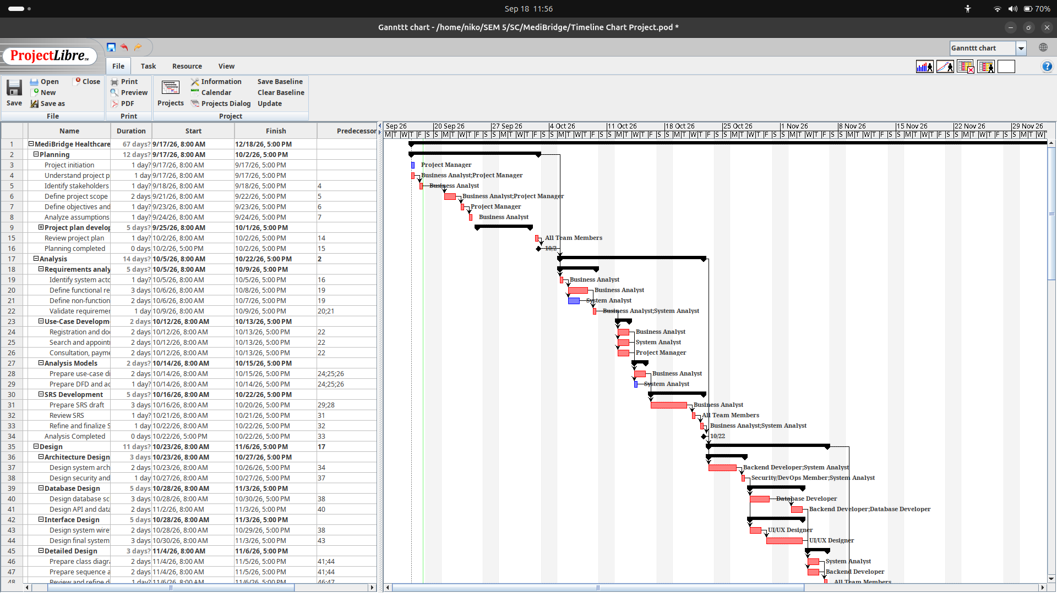

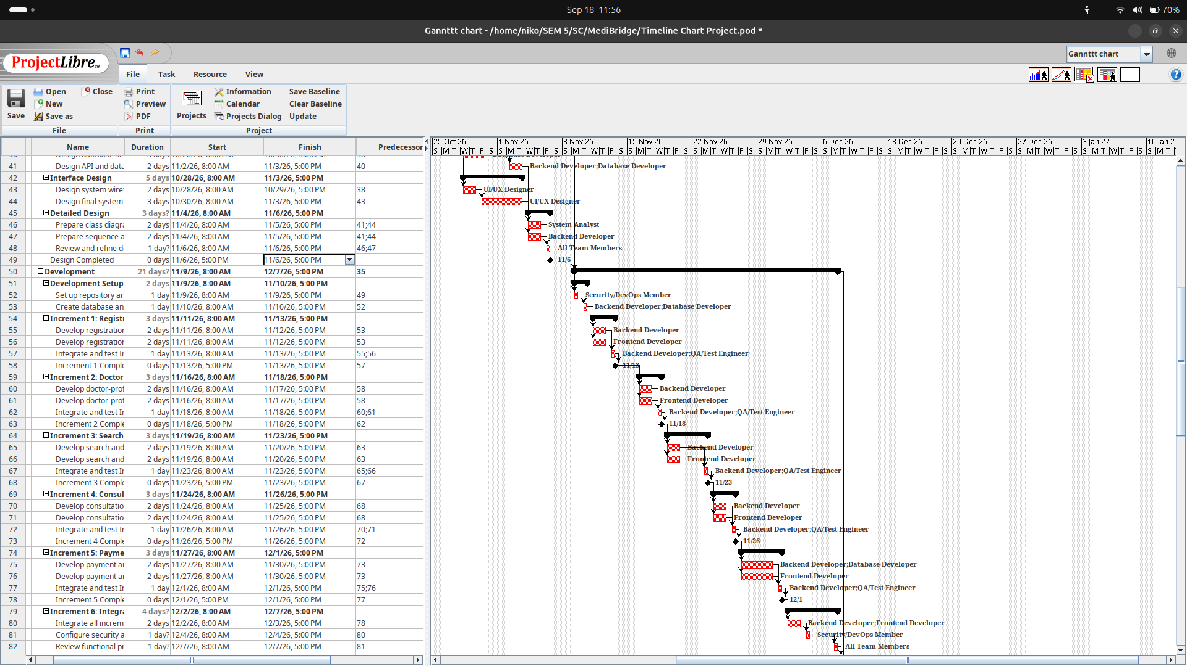

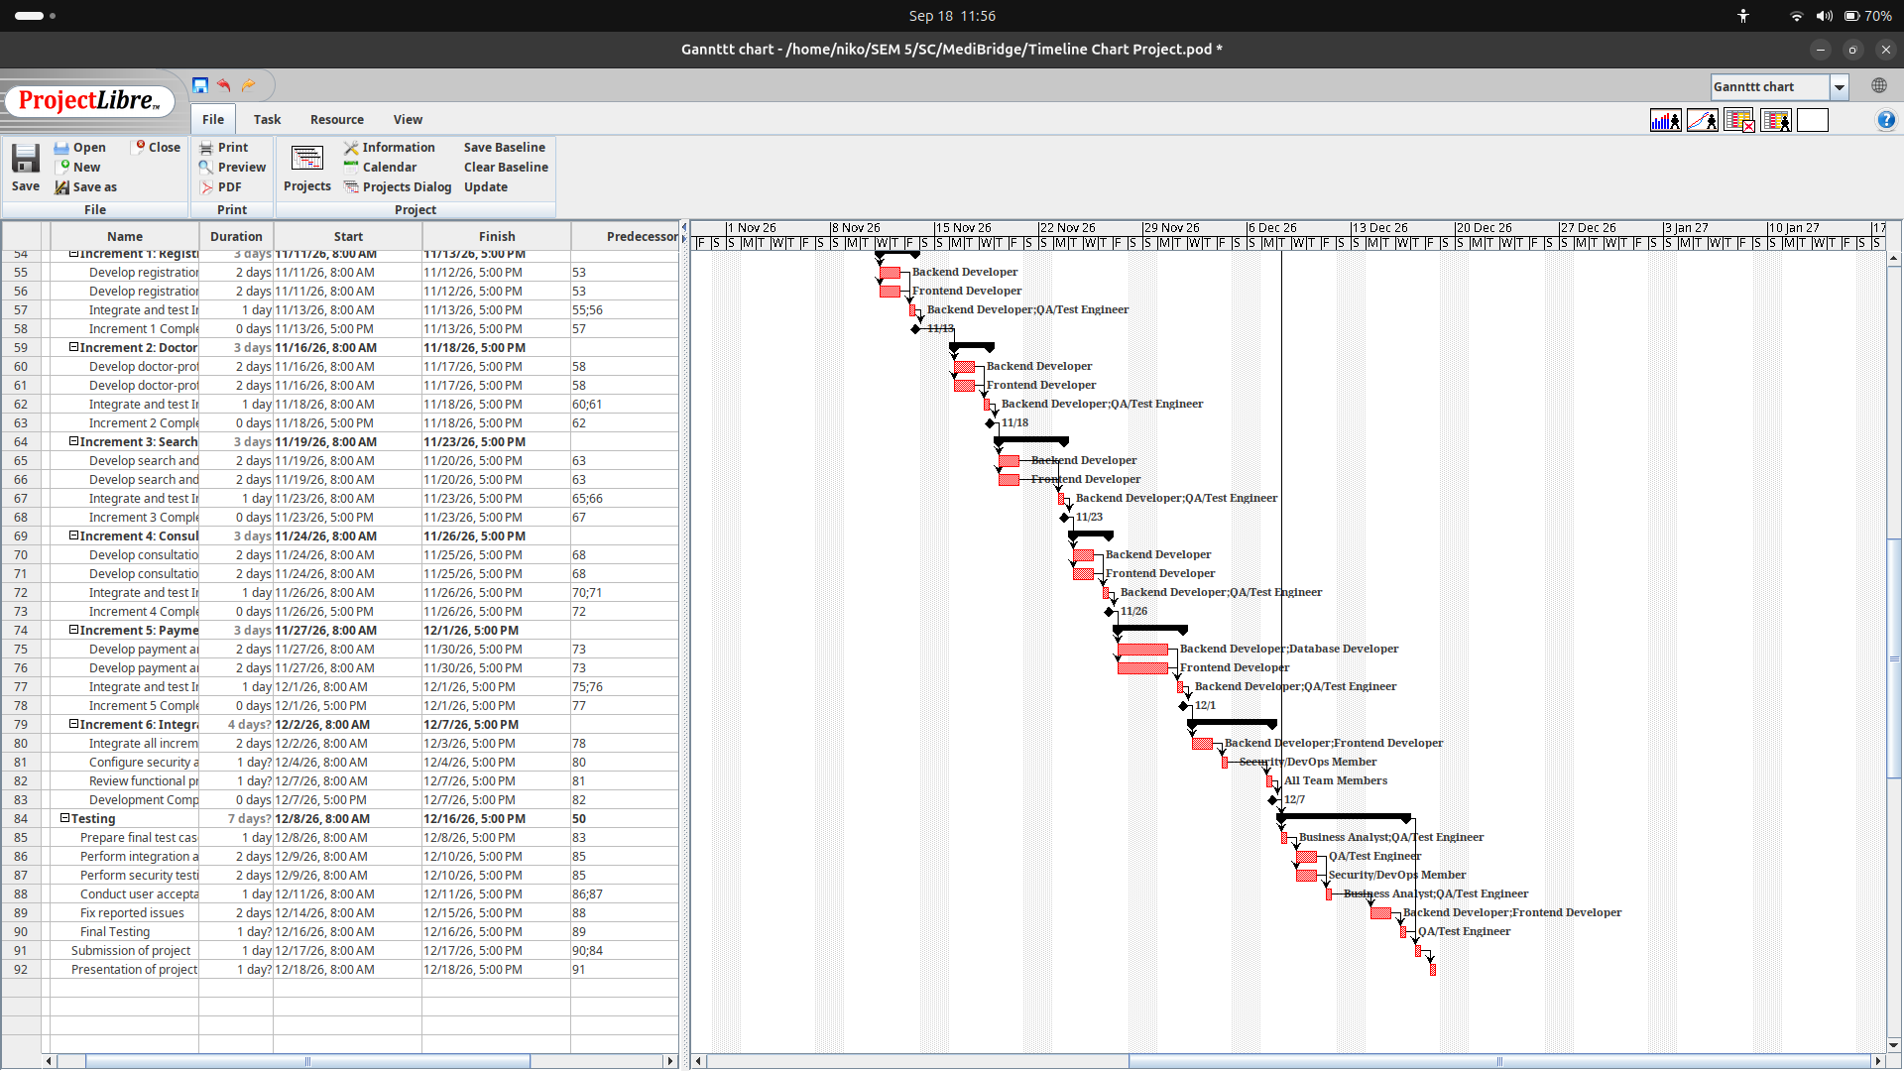

5.2 Work Activities
5.3 Schedule Allocation:
  - Project Setup & Initial Planning (Duration: 2 Weeks)
Define project scope, set up the development environment, and prepare the project management tools.
Key Activities:
- Set up the GitHub repository for version control.
- Design the system's database schema in MySQL.
- Set up VS Code as the development environment.
- Develop a detailed Gantt chart in ProjectLibre to outline the overall project timeline and dependencies
  - Requirements Analysis (Duration: 2 Weeks)
- Gather requirements from patients and doctors on what the system should do.
- Prepare the Software Requirements Specification (SRS) document.
- Create use case diagrams for the main features (search, booking, lab results).
  - System Design (Duration: 2 Weeks)
- Designing the system architecture (how data flows from front-end to back-end).
- To create database schema and plan the structure of tables in MySQL.
- Designing the UI for the registration page, submission system, feedback form, and progress tracking page.
  - Development Phase(4 Weeks):
- Sprint 1: User Registration and Login (Duration: 2 Weeks)
- Sprint 2: Doctor Profile and Search (Duration: 2 Weeks)
- Sprint 3: Appointment Booking and Consultation (Duration: 2 Weeks)
- Sprint 4: Lab Test Results and Payments (Duration: 2 Weeks)
  - Testing Phase(Duration: 1 Week)
- Perform integration testing on all system features to ensure everything works together.

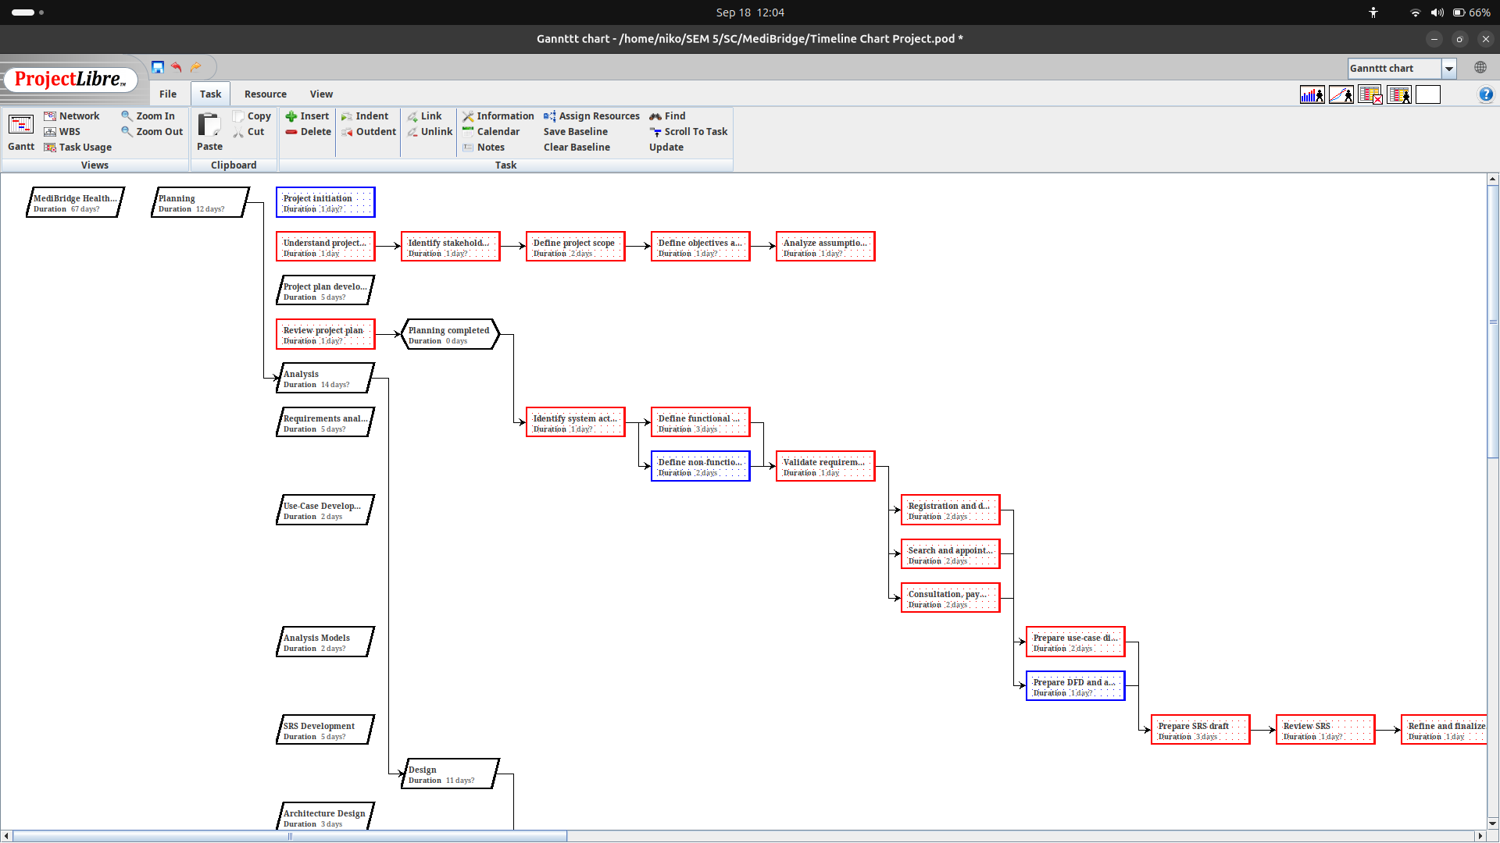
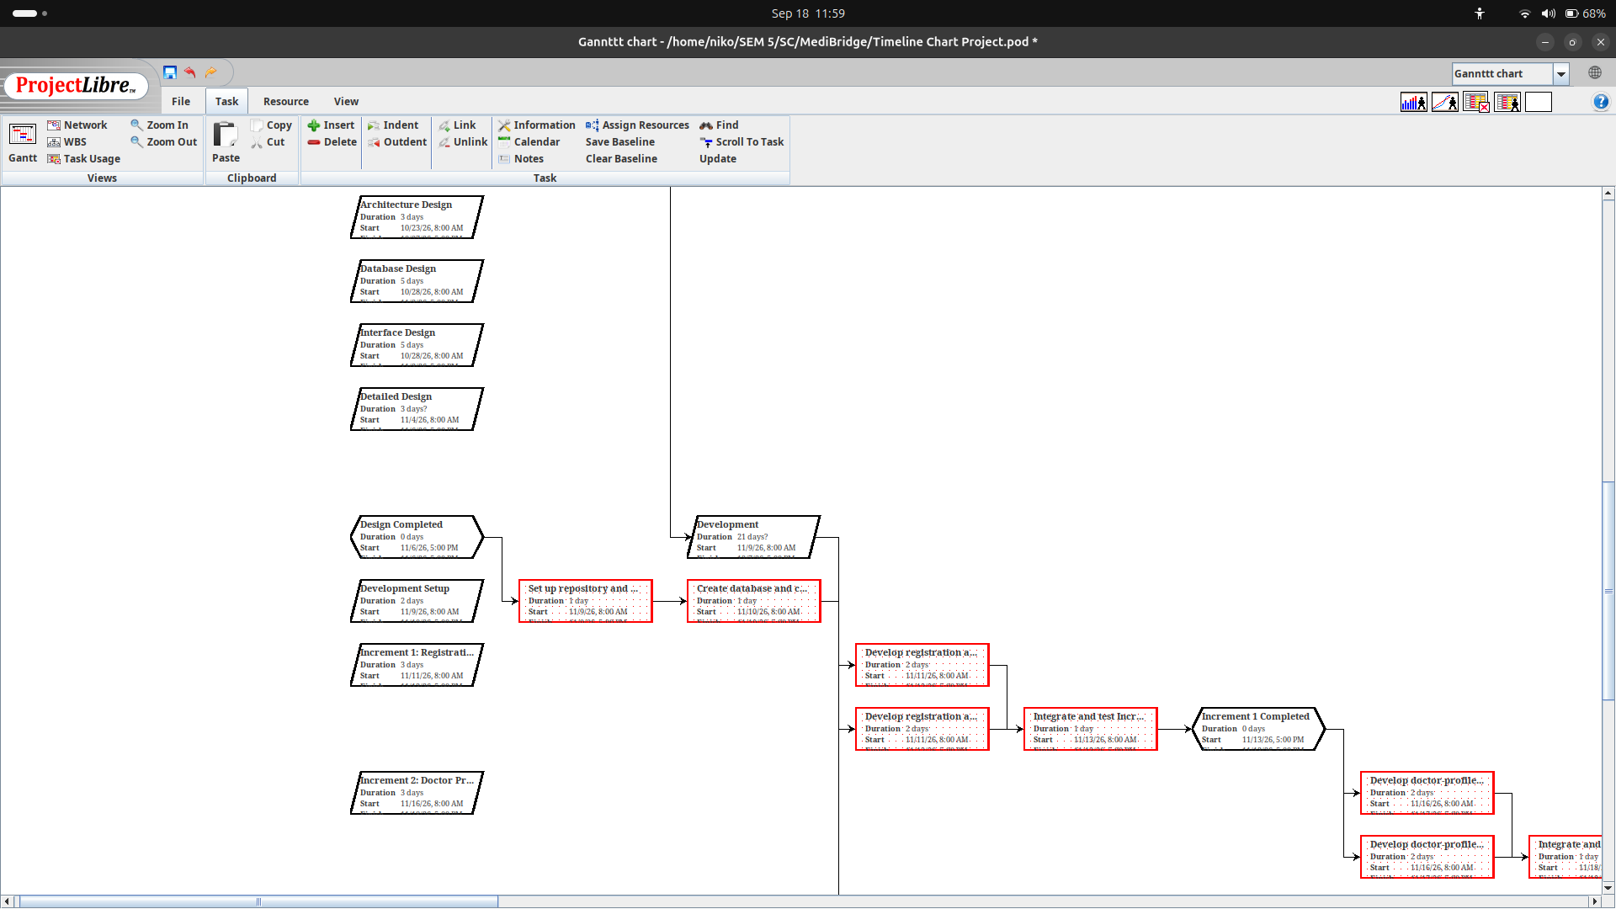
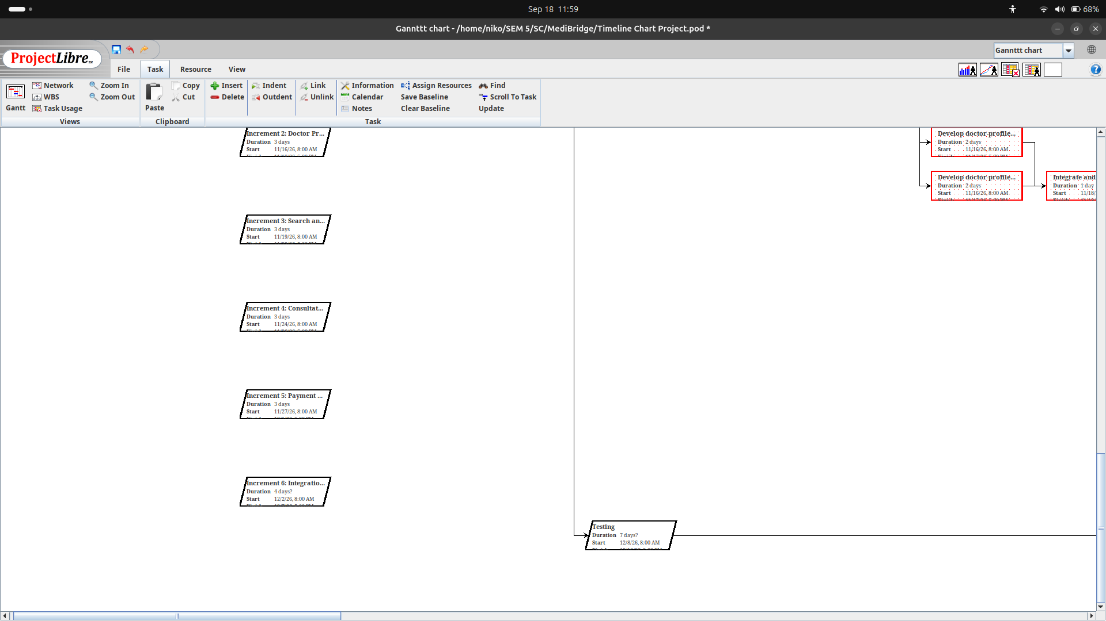
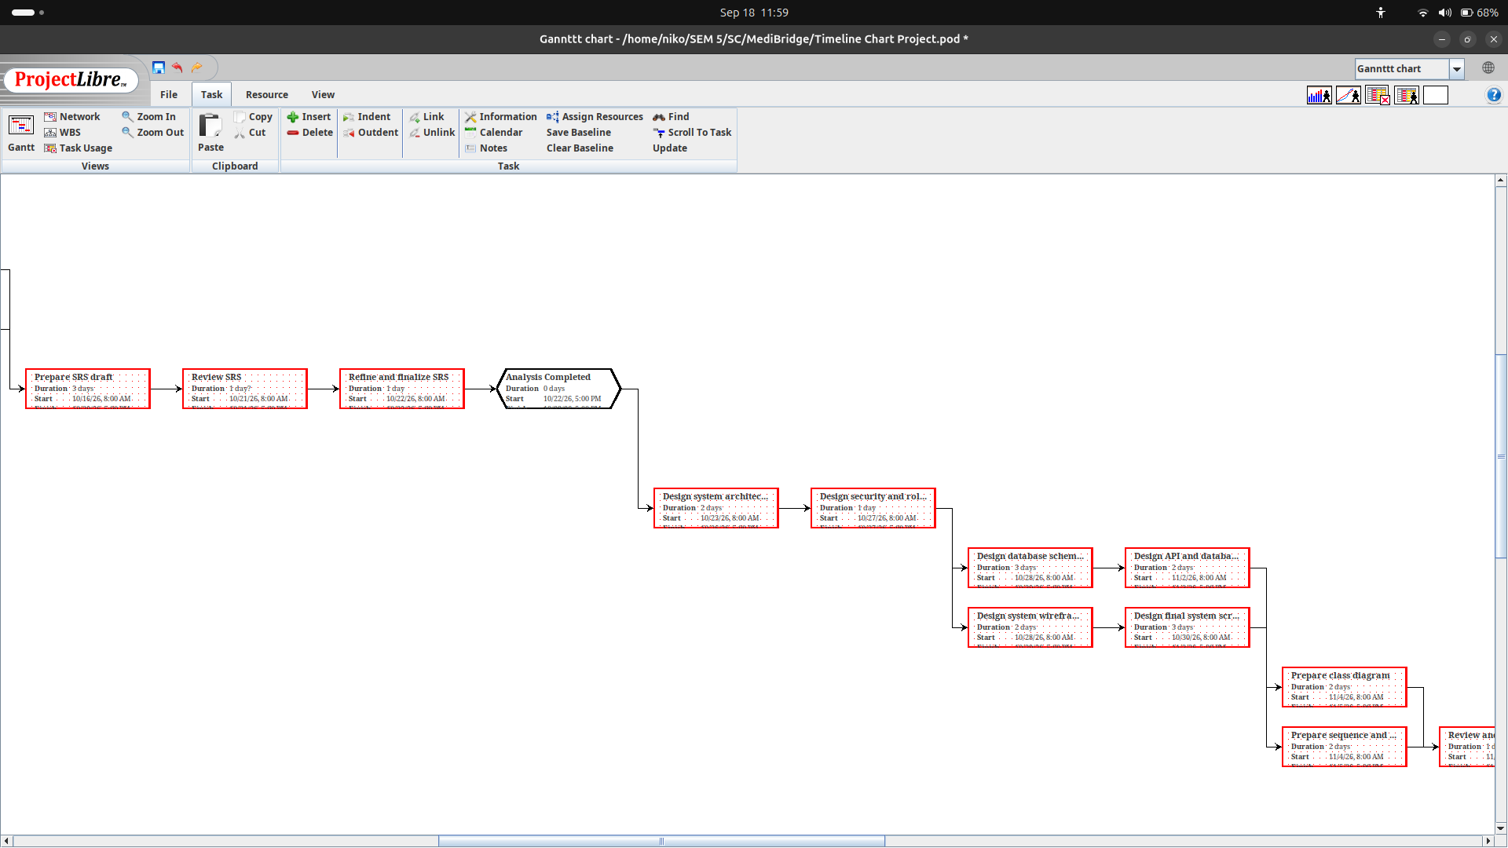

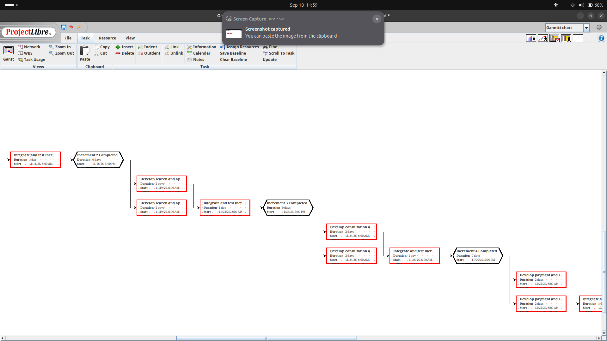

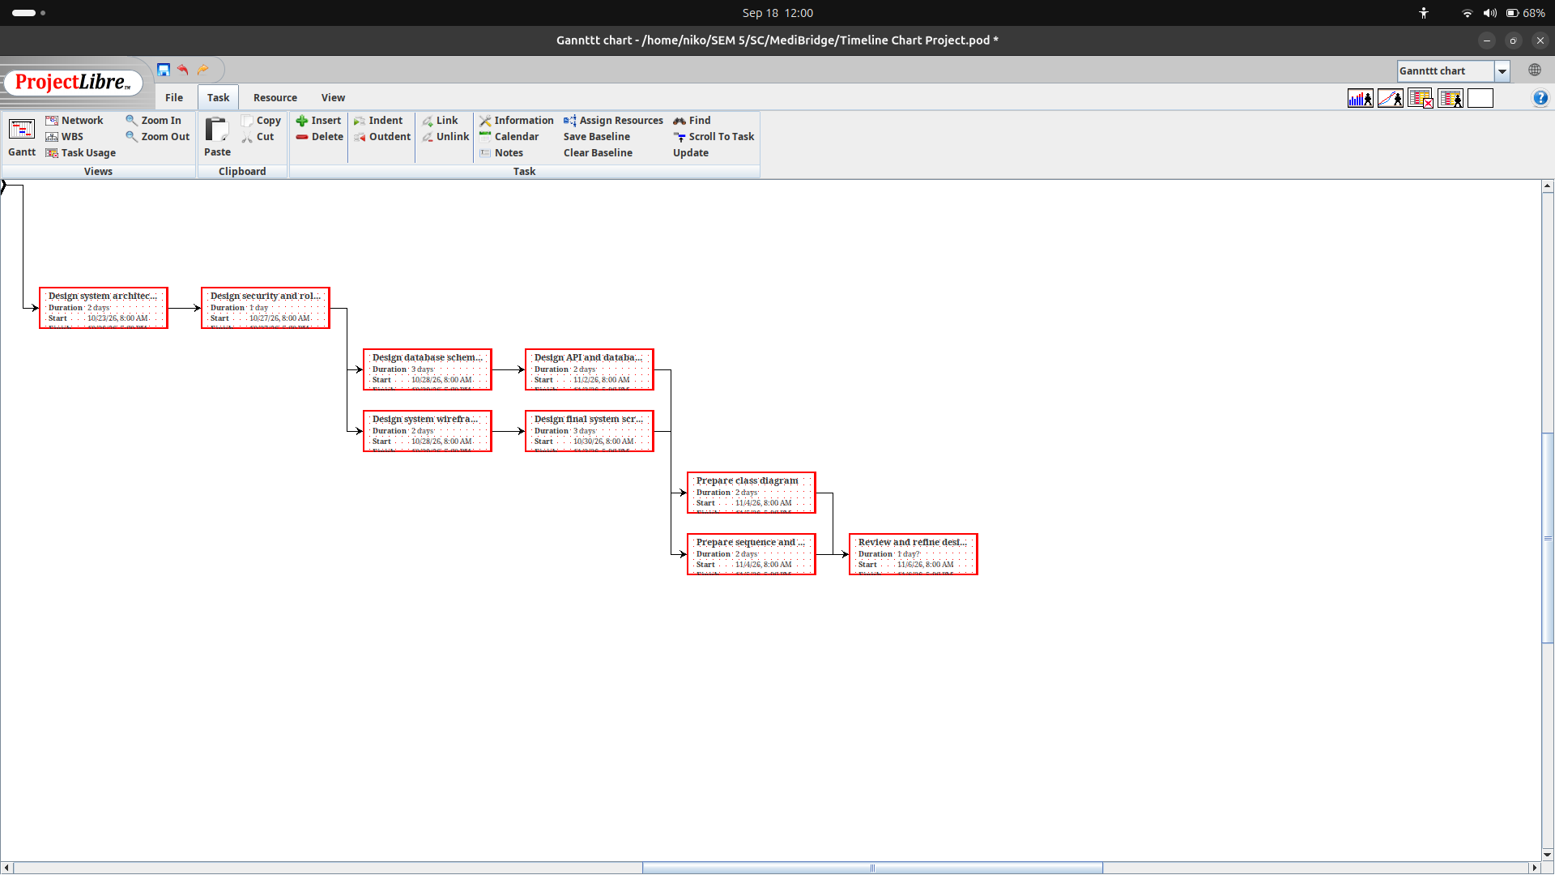

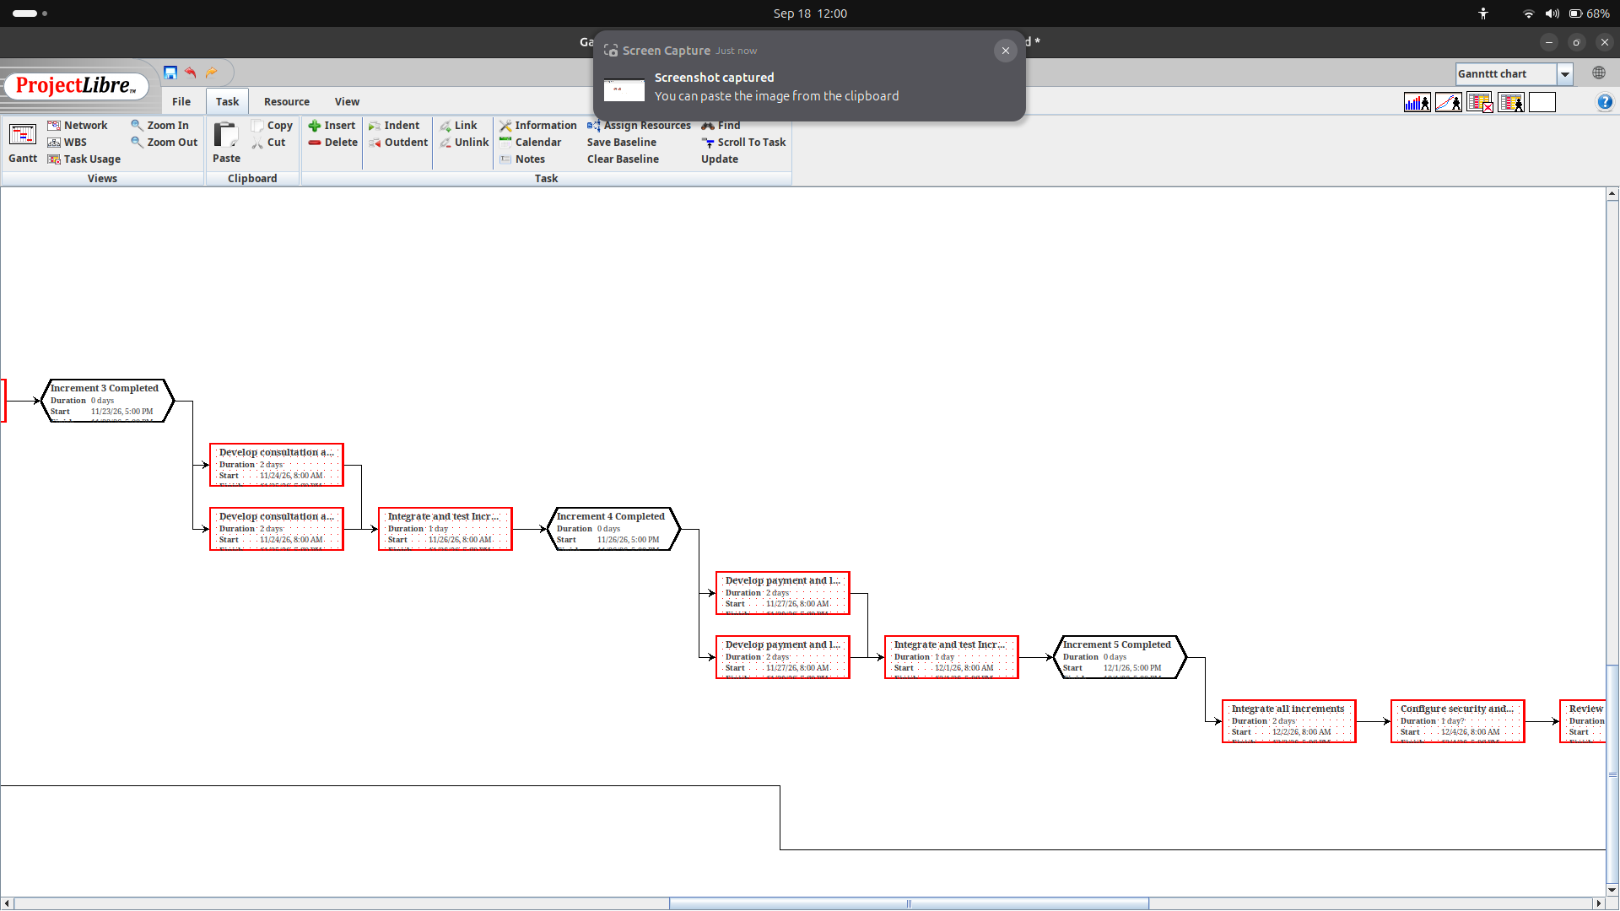

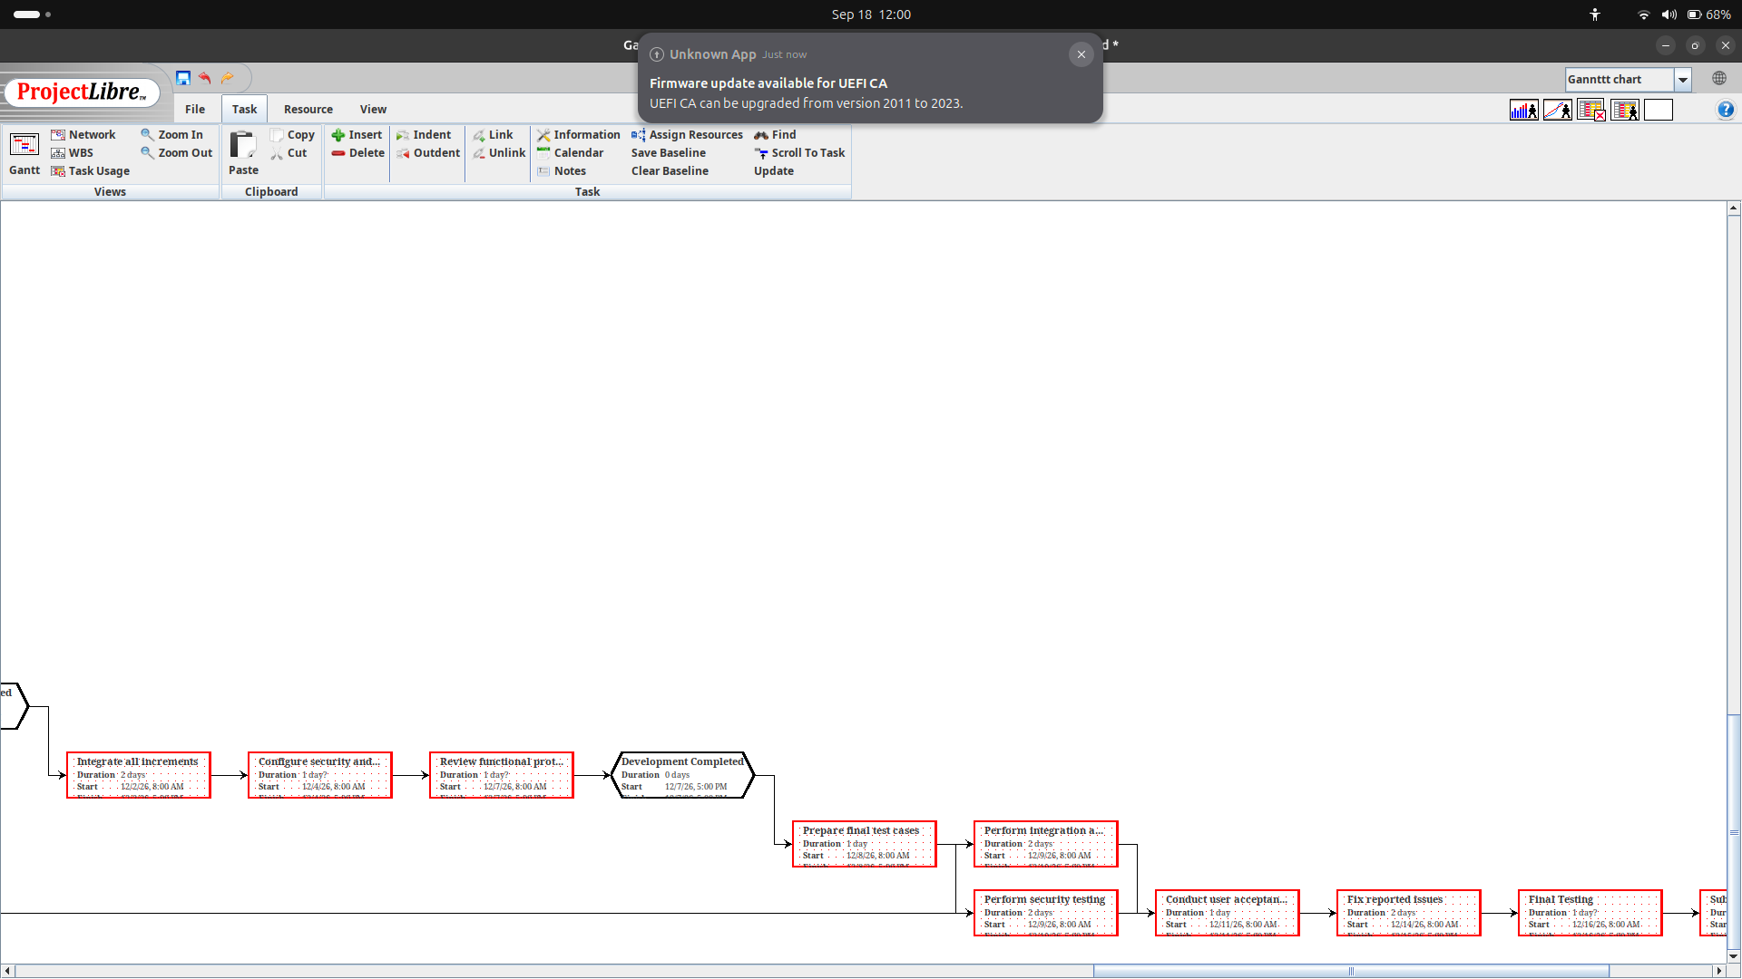
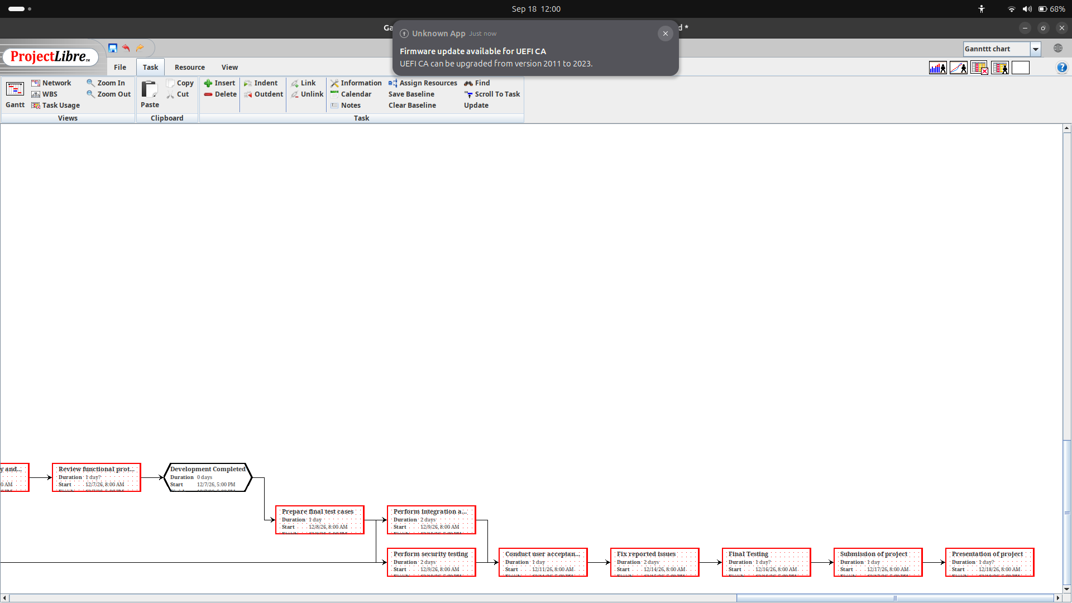

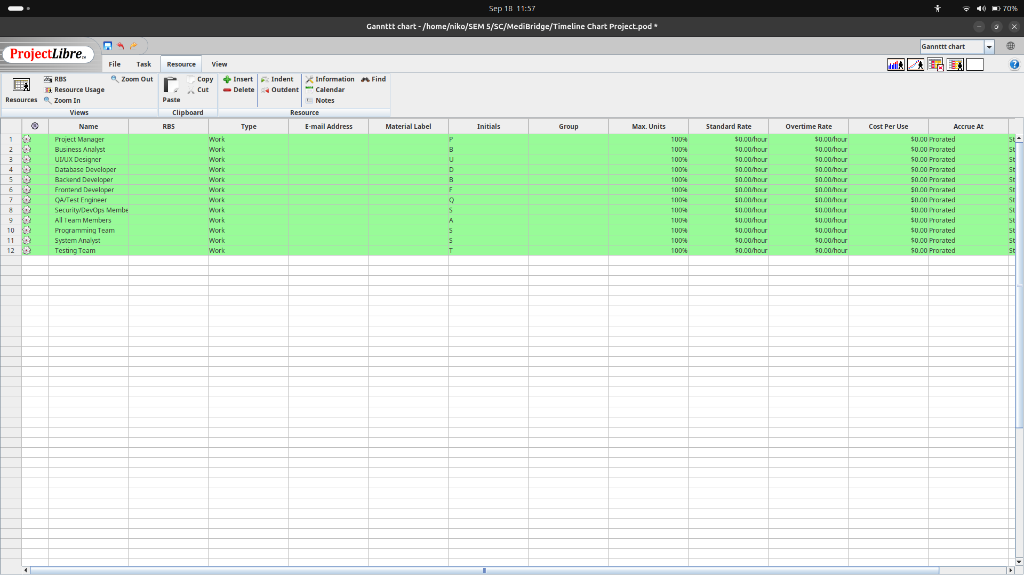
5.4 Resource Allocation:

6. Supporting Process Plans:

6.1 Risk Management

6.1.1 Risk Identification:
Technical Risks
Lack of Development Team: The team may have limited knowledge or experience with the programming language assigned for the project. This could create difficulties during the development process, especially when writing code, implementing different functions, and integrating various system components. As a result, development may take more time and the risk of programming errors may increase.
Probability | Impact
Medium | High
Data Security: System will store sensitive information such as patient and doctor details, appointments and laboratory test .Improper security may allow unauthorized user to stole the information.
Probability | Impact
Medium | High
Operational Risks
Development Delays: Academic responsibilities (exams, other projects and assignments) may slow the project progress
Probability | Impact
High | Medium
Resource Availability: Limited Availability of Resources and tool may lead failure or affect the project development
Probability | Impact
Medium | Medium
Scope Changes: Request for adding new functionality may affect the such as new search options or may add new actor may affect the scope and overall the project because everything is connected with each other
Probability | Impact
Medium | Medium

User Requirements change: Changes in patients and doctors requirements may affect the overall development of the system

6.1.2 Risk Analysis:
Probability and Impact Assessment: Risk can be analyzed according to the probability and its impact on our whole PULSE System . Probability can be categorized into low high and medium and how good or bad the consequences of the risks will affect the system.
Risk Prioritization: Risks can be prioritized by the difficulty of the risk. If risks is related to the patient checkup and about the laboratory test , the first priority is to facilitate the patient and rest will solve later.

6.2 Risk Mitigation Strategies
Technical Risks
Code Reviews & Pair Programming: Review the code thoroughly of the assigned language and communicate with each other to solve the risks in a better way.
Security Measures: Use role-based access and Authentication help to ensure that patient and doctors will only see the information related to their roles
Module Testing: Test different modules separately such as doctor registration will be tested then user registration will be tested and later on laboratory tests will be tested separately and in the end we integrate all the modules
Data Validation: Input validation will be used to reduce incorrect or incomplete information when users enter patient, doctor, appointment, or laboratory data.
Operational Risks
Clearance Project Planning: Use a Gantt chart to put in deadlines and divide up the tasks equally.
Requirement Review: System requirements will be reviewed regularly to ensure that the developed features meet the needs of patients, doctors.

6.3 Risk Monitoring and Control
Regular Risk Reviews: The risk will be revived after each increment and after each increment check the risk probability and affect
Risk Register: A MS Word File will be maintained that contains all the risks that occurs during the development , and after each increment all the risks will be updated
Regular Communication: The development team will communicate with the stakeholders after each increment.

USE CASE DIAGRAM
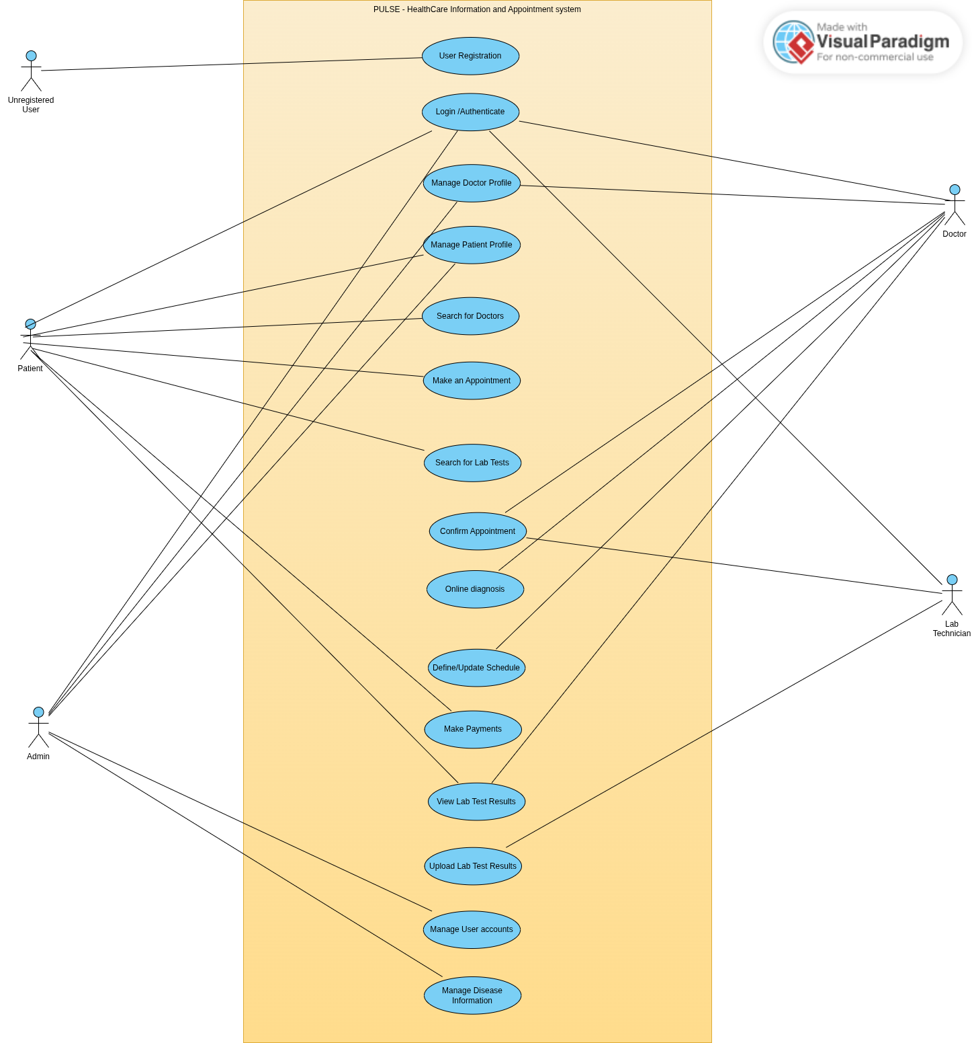

CHANGES MADE:
Scope :
Added the following use cases:
- User Login and Authentication.
- Manage disease information.
- Make online payments.
- Upload lab test results.
- Provide online diagnosis.

